Library Discussion Room Booking System

1. DOCUMENT OVERVIEW
Project Name: Library Room Reservation Manager
Status: Professional SRS
Implementation Model: Frontend (HTML/CSS/JS) + Backend (Airtable/Serverless)

2. SYSTEM SCOPE & BUSINESS RULES
The system provides a seamless booking experience for students while enforcing strict anti-abuse policies without requiring a login account.

Core Business Rules:
- Duration: Every booking is strictly 1 hour.
- Group Size: Minimum 3 members, maximum 6 members.
- Daily Quota: A user (by Student ID) is limited to 1 reservation per day.
- Reservation Cap: A user can have a maximum of 3 future reservations active at any time.
- Advance Booking: Users can only book for the next 3 working days.

3. FUNCTIONAL REQUIREMENTS

3.1 User Interface (Frontend)
- FR-01 (Room Management): The system shall manage two specific rooms: Room 1 (with Projector) and Room 2 (with Smart TV).
- FR-02 (Date Logic): The calendar must dynamically calculate the next 3 working days and disable weekends (Saturday/Sunday).
- FR-03 (Slot Visuals): Slots must show real-time availability:
  - Green: Available.
  - Yellow: Pending (Joinable Queue).
  - Red: Confirmed (Occupied).

3.2 Booking Constraints & Validation
- FR-04 (Identity Capture): The system must capture the primary applicant’s Name, Student ID, Email, and Phone.
- FR-05 (Group Member Validation): The system shall enforce a minimum of 2 additional group member entries (3 total) before allowing submission.
- FR-06 (ID Uniqueness): The system shall verify the primary Student ID against the target date in the database. If a record exists, the booking is rejected.
- FR-07 (Weekly Cap): The system shall count active records for a Student ID. If total active $\geq 3$, the booking is rejected.

3.3 Admin Panel
- FR-08 (Dashboard): A master view for librarians to see the daily grid of both rooms.
- FR-09 (Manual Override): Admin can manually confirm a "Yellow" slot to "Red" upon group arrival or cancel it back to "Green."

4. DATABASE ARCHITECTURE (ERD)

Table: Rooms
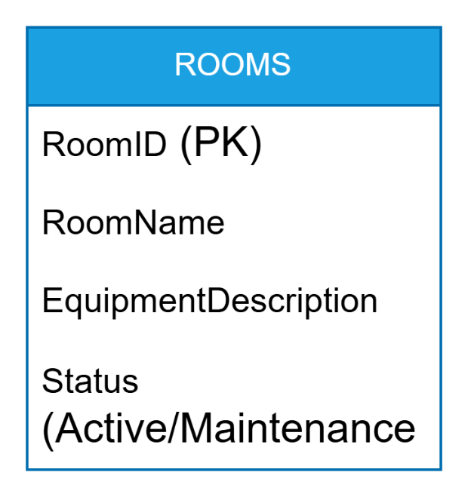

Table: Bookings

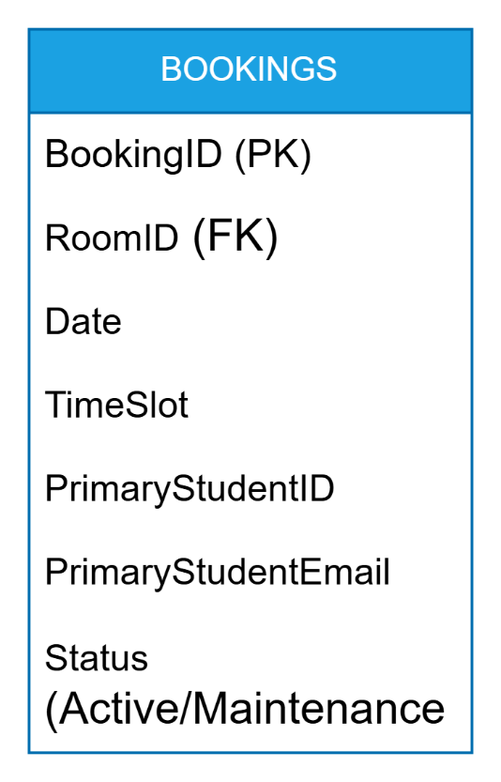

Table: GroupMembers
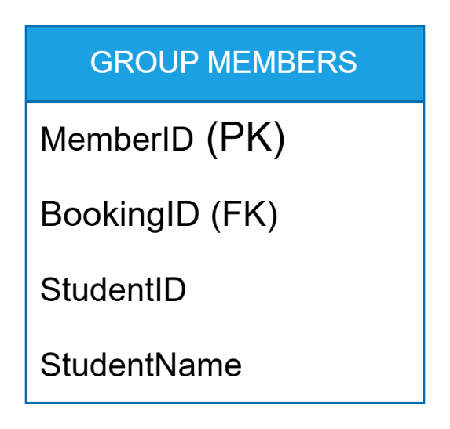

5. SYSTEM WORKFLOWS

5.1 The Booking Sequence (Backend Logic)
- Submission: User clicks "Confirm."
- Pre-Check: Backend validates the MemberCount.
- Conflict Check: Backend queries DB: WHERE StudentID = UserID AND Date = CurrentSelection.
- Cap Check: Backend queries DB: COUNT(*) WHERE StudentID = UserID AND Status != "Completed".
- Write: If checks pass, data is committed to the database.

5.2 Queue Logic
If a user selects a "Yellow" slot, the system stores the data with a Status = "Queued". If the primary user is a "No-show" (Admin triggers cancellation), the first user in the queue is automatically notified via email.

6. NON-FUNCTIONAL REQUIREMENTS
- Concurrency: The system must use database locking to prevent two users from booking the same slot at the exact same millisecond.
- Responsiveness: The UI must be fully mobile-responsive for students booking while in the library.
- Data Integrity: Valid IDs (length and format) must be checked on the frontend to prevent junk data.

